Applying Pivot tables for analytics

1. Which year had the highest revenues overall and how much were revenues during that year?

* Year 2013 –Revenue VALUE: $ 32,771,771.13

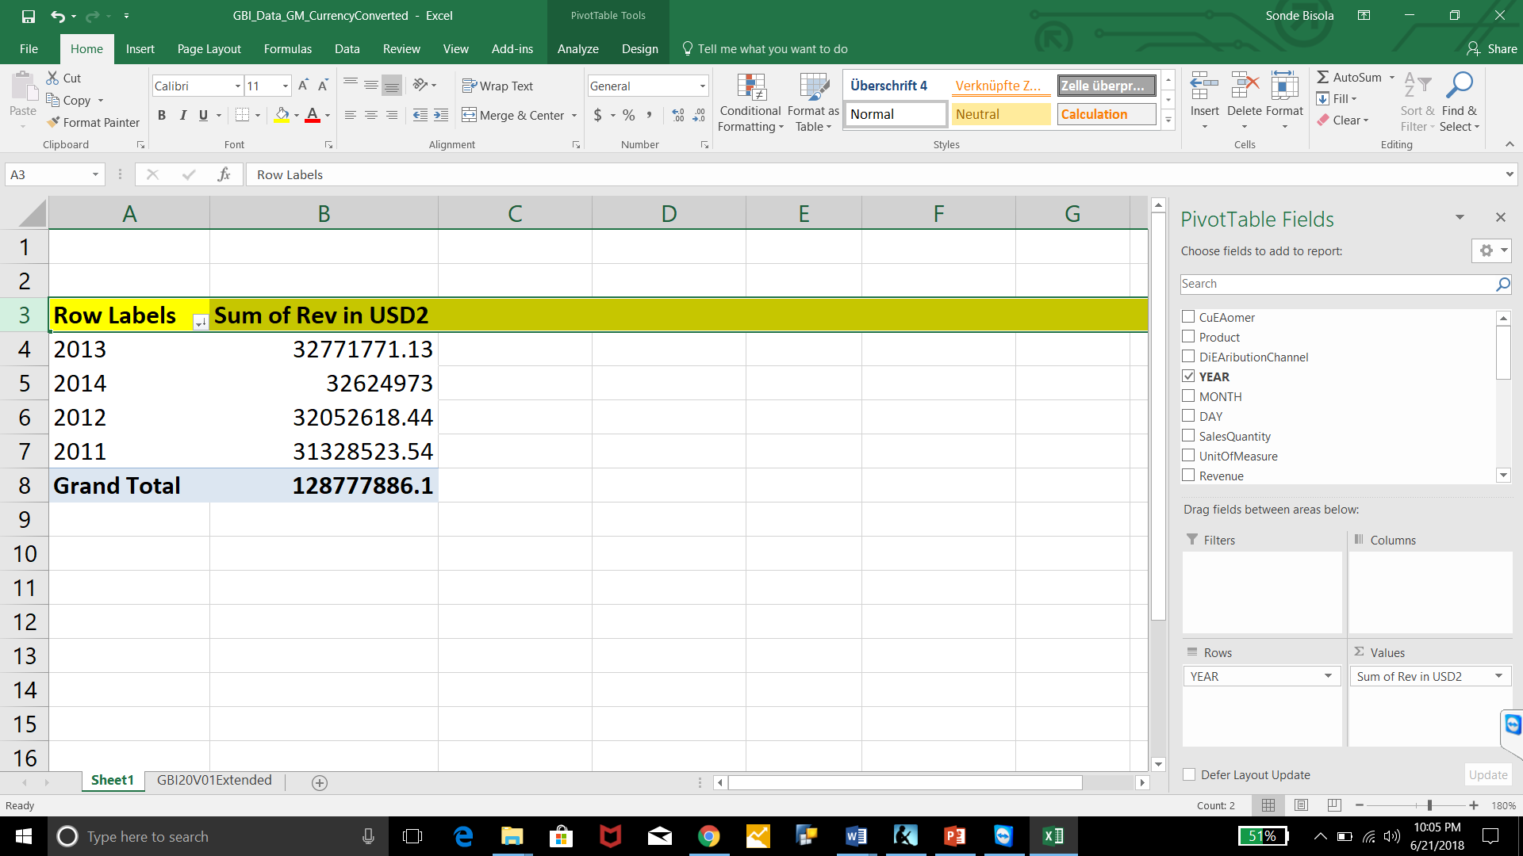

1. What was the year with the highest overall gross margin and what was the amount?

* 2013 had the highest overall gross margin; valued at $10,130,599.67

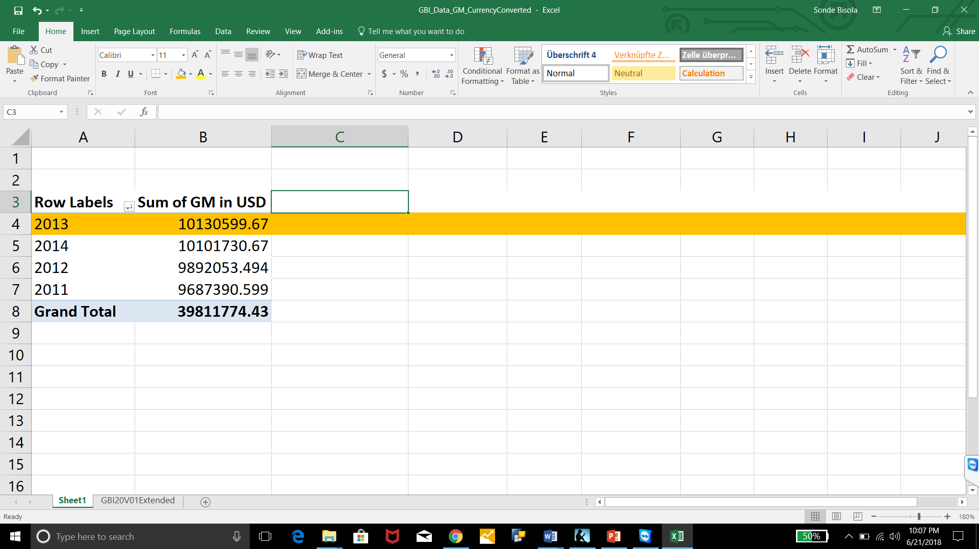

* 1. Based on what you know about the relationship between revenue and gross margin, does this result make sense?
* Gross margin is (revenue – cost.) Therefore although it is not always the case, the year with the highest revenue is most likely going to be the yesryear with the highest gross margin. Which in our case is 2013.
  1. During this year, what was the gross margin for Germany and what was it for the U.S.?
* Gross Margin Germany: $ 4,672,502.02
* Gross Margin US: $5,458,097.65

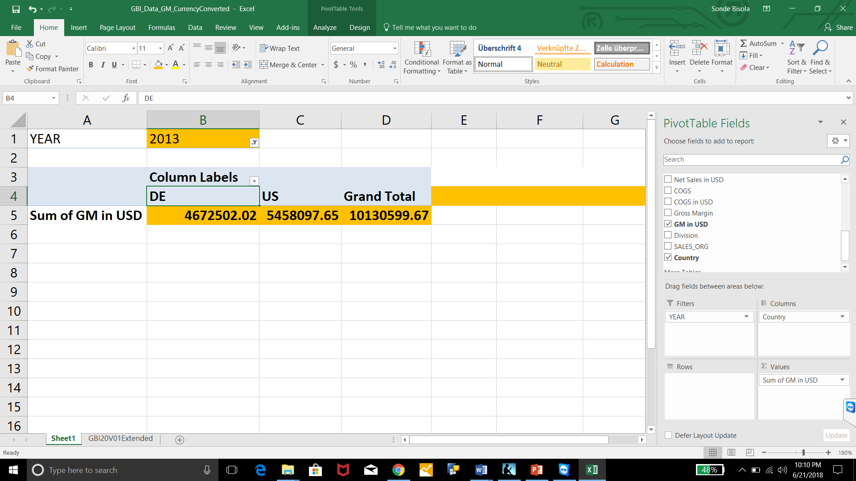

* 1. What was the gross margin as a percentage of sales for Germany and for the U.S.?
* Gross Margin as a percentage of sales US: 33.83%
* Gross Margin as a percentage of sales Germany:29.90%

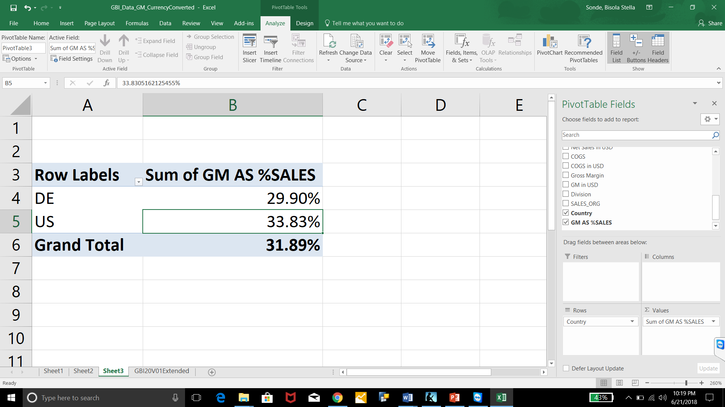

1. Compare gross margin ratio by division for **all years** (in total). What is the gross margin ratio for each division?

* Gross margin ratio for division BI :31.94%
* gross margin ratio for division AS: 28.88%

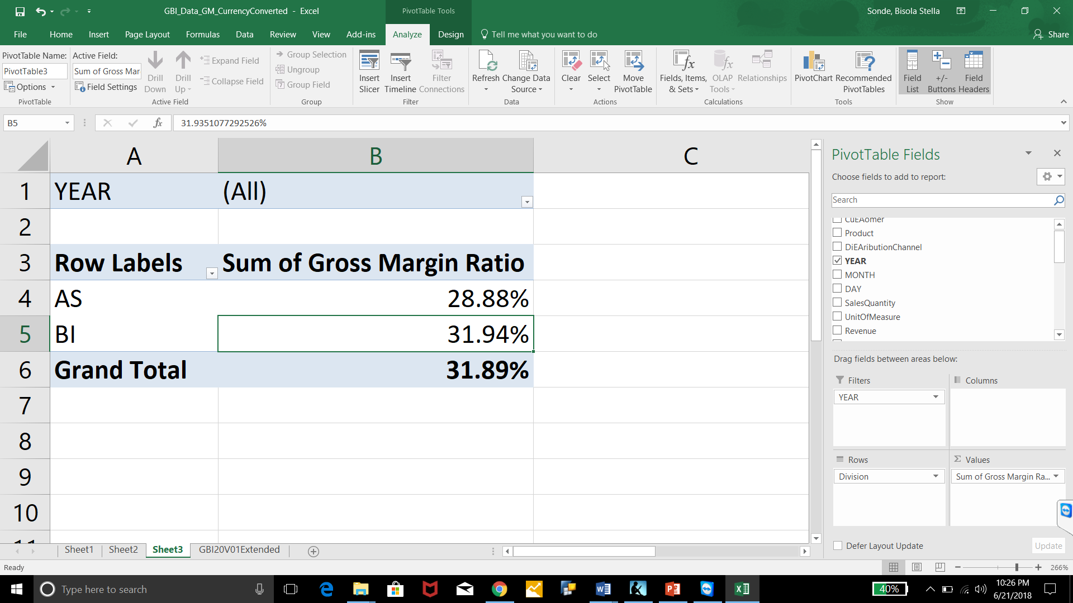

1. Which sales organization has the highest revenues for **2014**?

* US EA

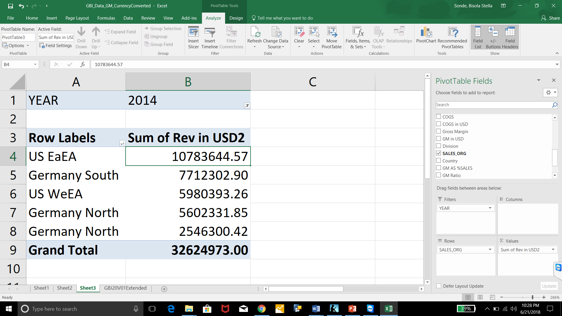

1. **In the year 2014**, which was the product with the highest sales in terms of quantities sold and what was that quantity?

* Air Pump Quantity 4,679.00

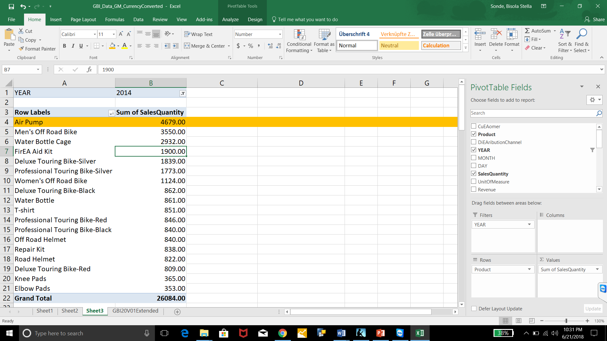

1. Which was the lowest selling accessory in terms of quantities sold during 2014?

* Elbow Pads Quantity: 353

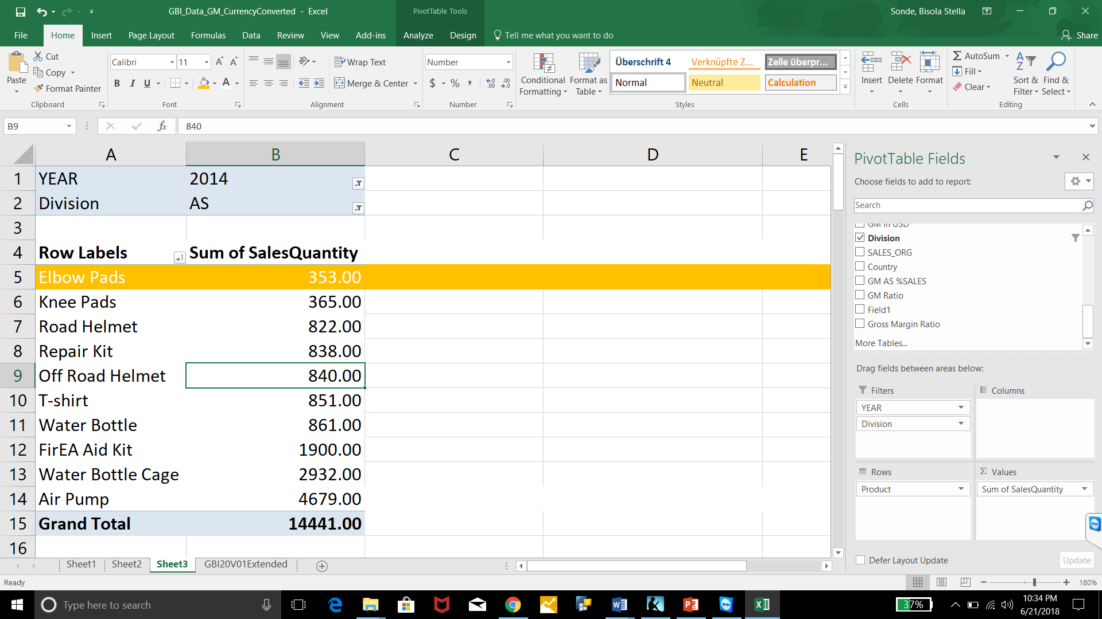

1. Which was the lowest selling bicycle in terms of quantities sold during 2014?

* Deluxe Touring Bike-Red

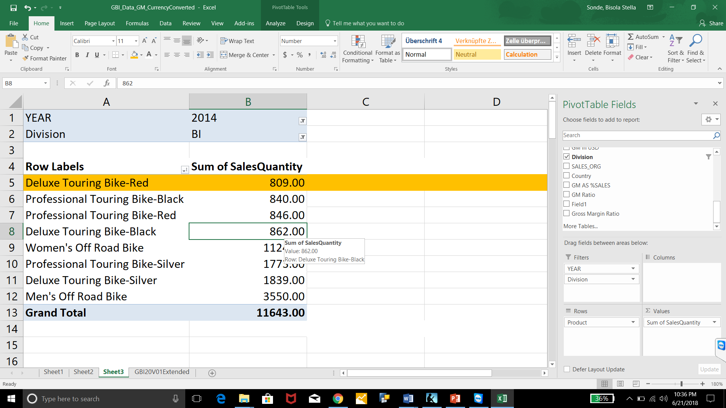

* 1. What was the gross margin for the sales of these bicycles?
* Gross margin for the sales of these bicycles : $739,395.88

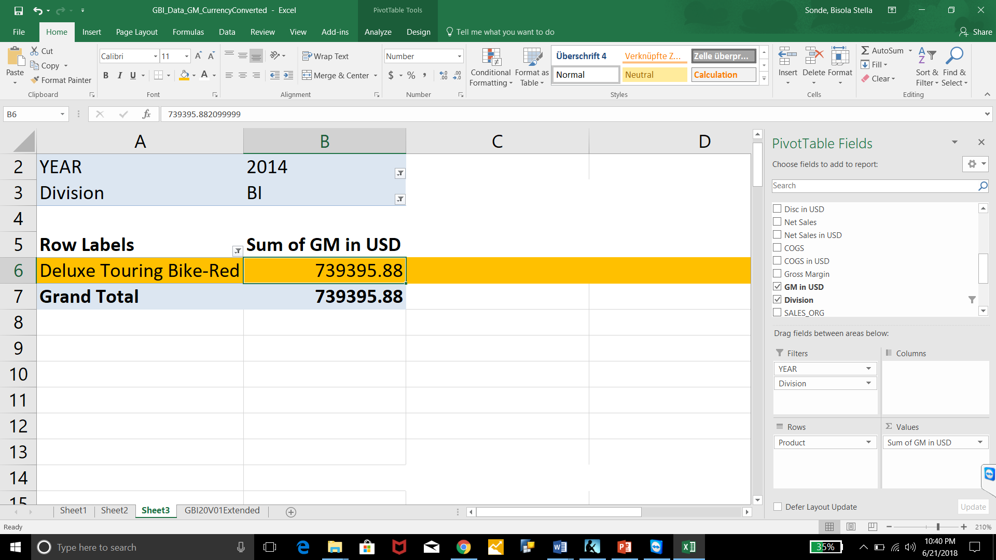

1. Compare sales discounts by country for **all years**. Which country has a higher sales discount as a percentage of sales and how much is it?

US : 3.32%

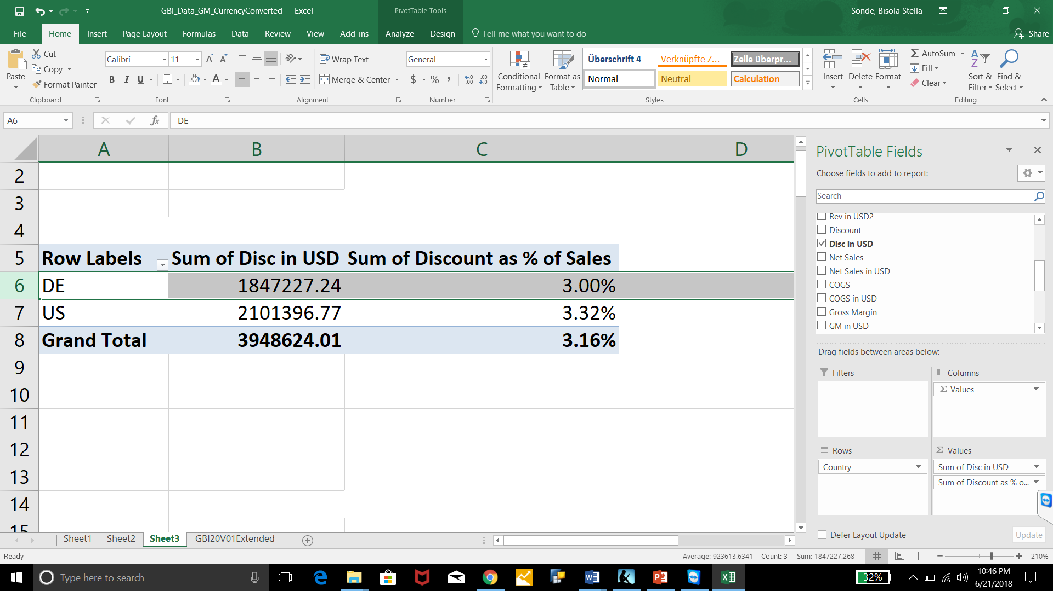

* 1. Does this sales discount percentage change over time? Explain.
* THE Sales discount for US cahnges over time. We can see below that it is not stable.

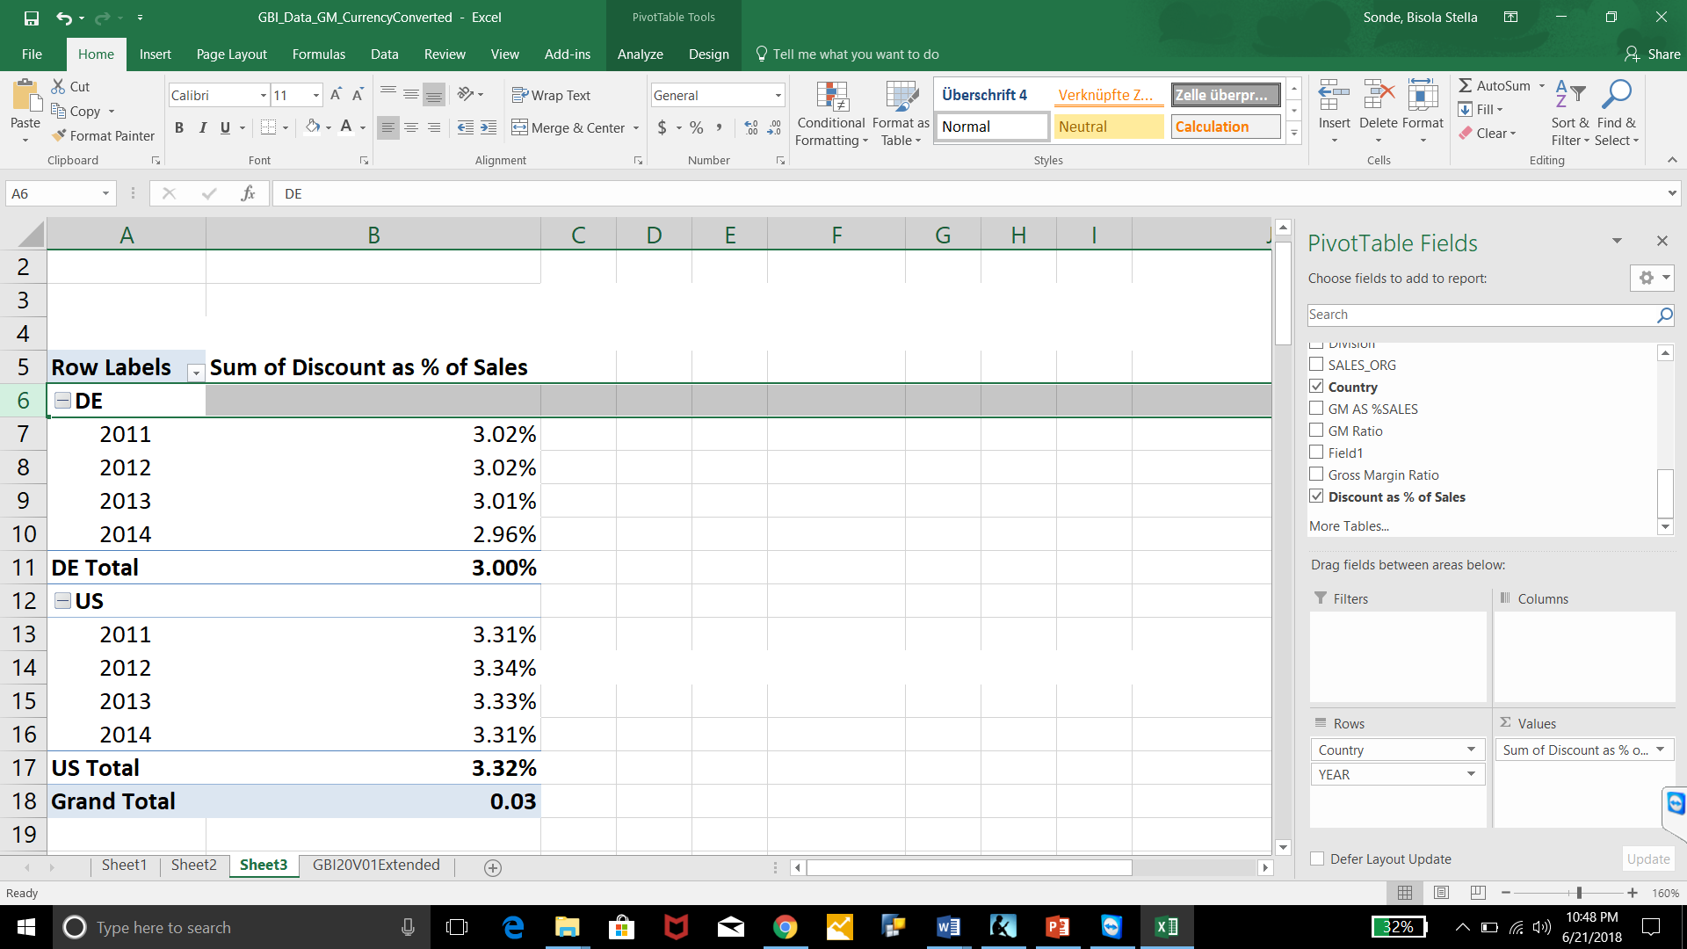

1. Which customer purchased the highest quantity of black deluxe touring bikes **on average** during the month of May for all years?

* Beantown Bikes

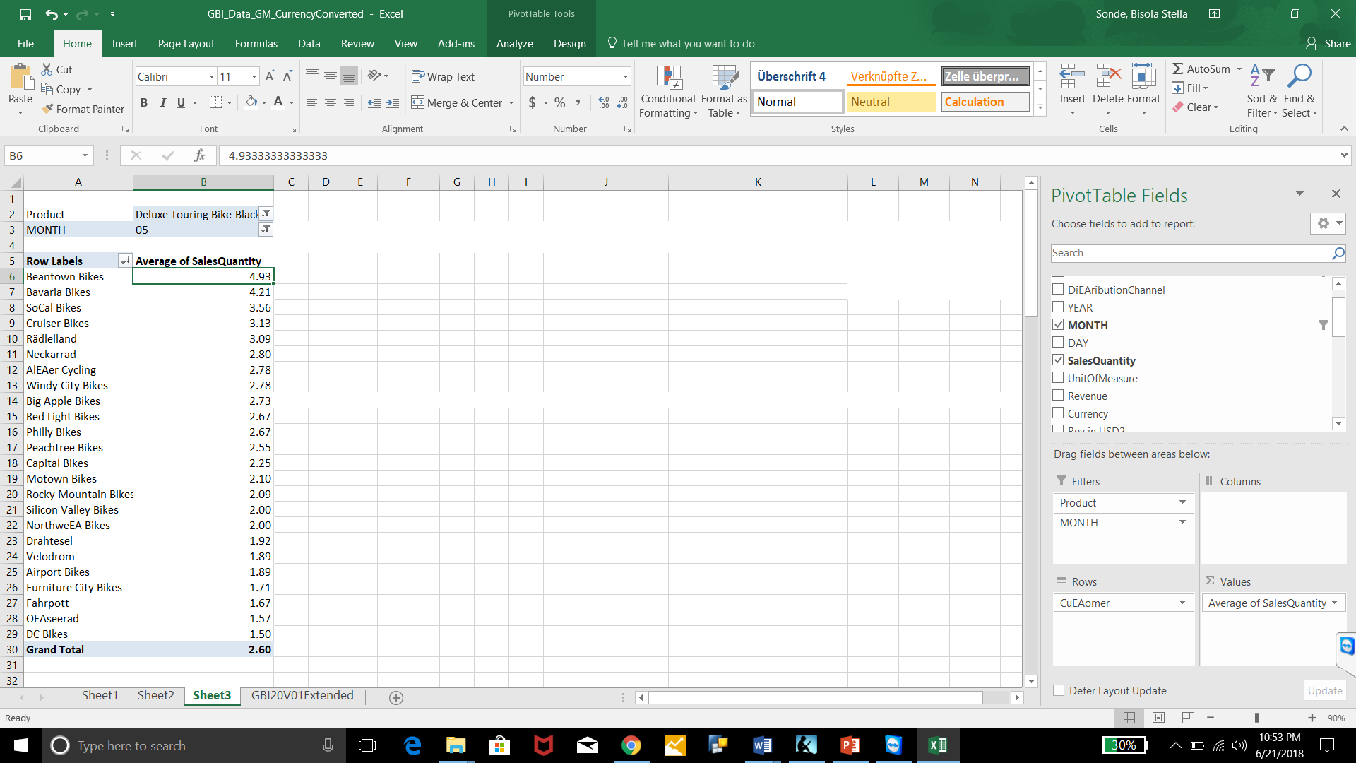

1. Use the “top 10” filter to determine which five customers have the lowest sales overall (**for all years**). What are the total revenues for these five customers?

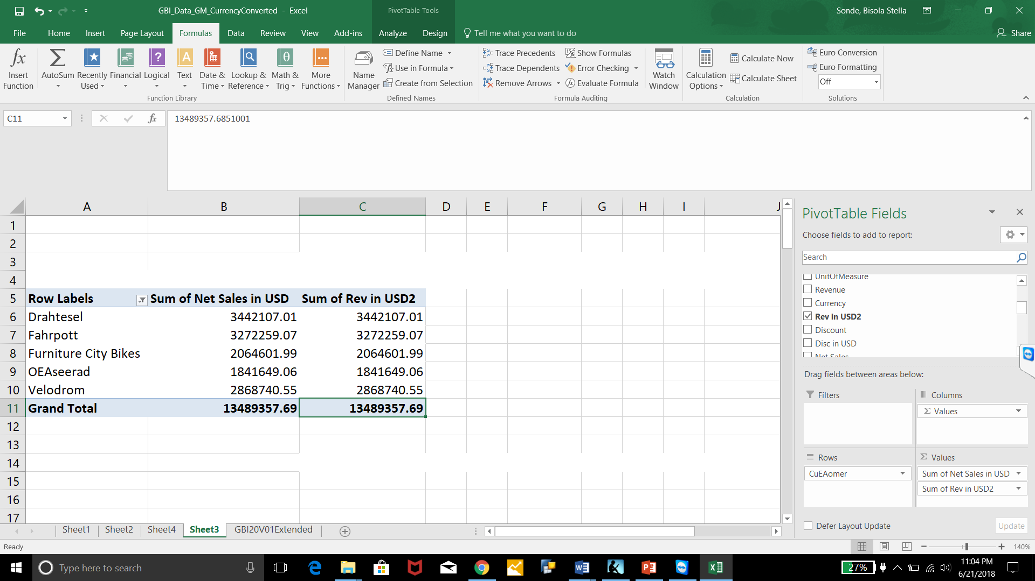

* 1. What are these five customers’ sales revenues and gross margin for each year?

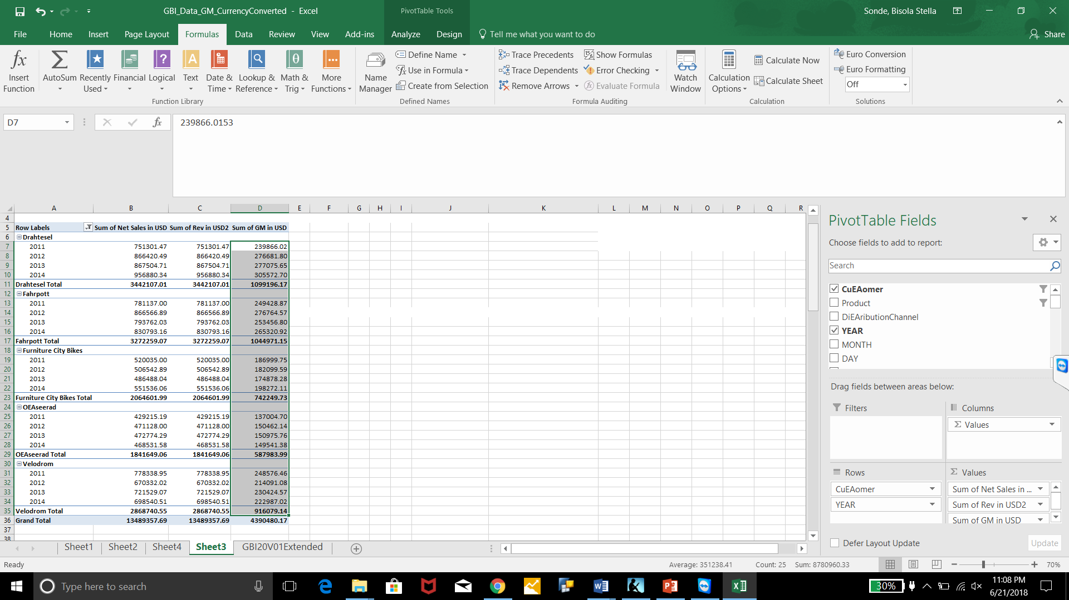

* 1. Are sales increasing or decreasing over time?
* We can see that the sales value is neither constantly increasing or decreasing over time.

1. Compare gross margin by product for **all years**. Which product has the lowest gross margin as a percentage of the total gross margin?

* Water Bottle.

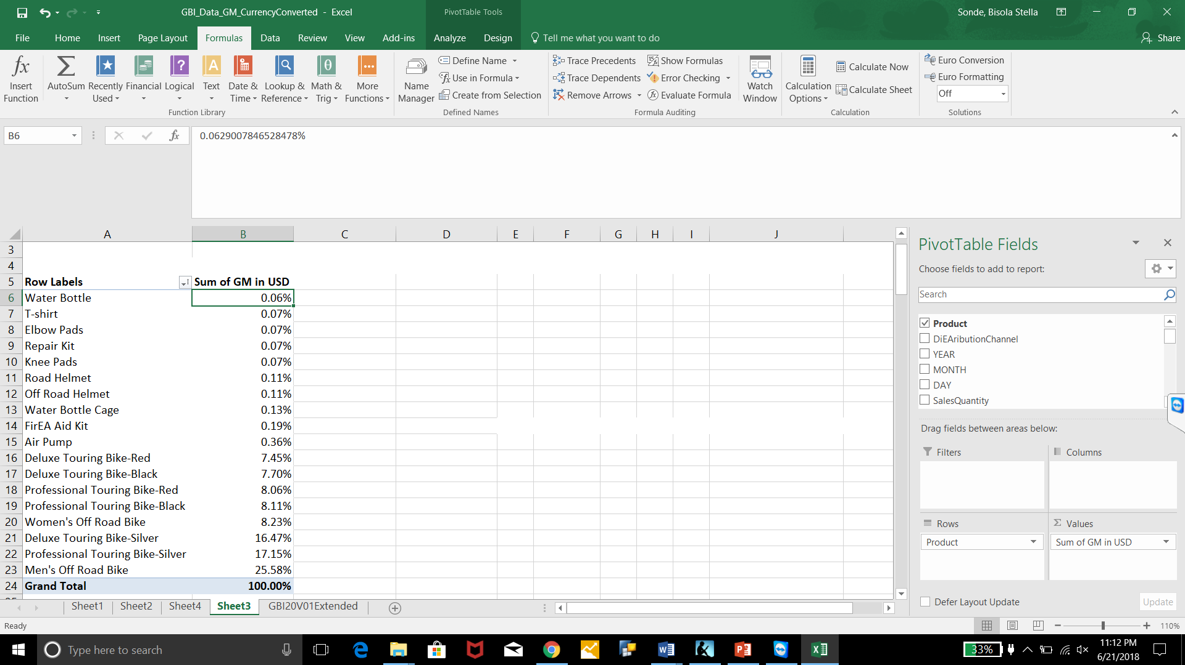

1. Create a query of your own to answer a question not asked/answered in the previous questions. Define the question, how you answered it and the answer you obtained from your pivot table. Why did you ask this question? Why is it important?

* Query Shows the most purchased good (Water Bottle) on July 4th in the US; Although this trend is not consistent for all years.

July 4th is the US Independence day

